3x3 Observations: December 2009
ENGLISH Department – 17 Classes

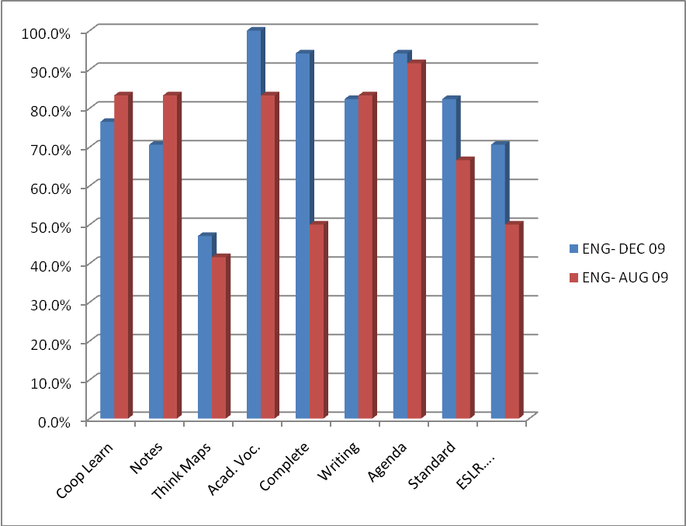

ENGLISH | Coop Learn | Notes | Think Maps | Acad. Voc. | Complete Sentences | Writing | Agenda | Standard | ESLR….
Dec 09 | 77% | 71% | 47% | 100% | 94% | 82% | 94% | 82% | 71%
Aug 09 | 83% | 83% | 42% | 83% | 50% | 83% | 92% | 67% | 50%

